數位訊號處理概論

Introduction to Digital Signal Processing: HW1, Quiz1, Topic2

TA Review

TA: 簡婉軒, Shreya

Department of Electrical Engineering

National Tsing Hua University

Remind

• HW 2:

• Due time: **2022/03/30 at 13:20**

• A4 papers and hand in the homework in class

• Please provide detailed answers or explanations in English

• Quiz 2:

• time: **2022/03/30 13:20-15:10**

• scope: everything we cover in topic 2

• in eeclas 206 and 208

• 1 A4 cheat sheet is allowed, and printed from iPad is not accepted.

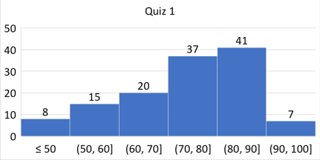Avg: 73.56 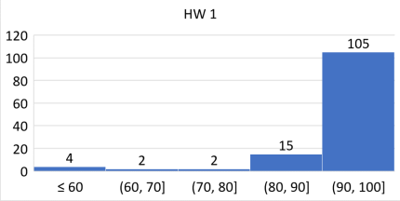Avg: 92.20

HW1-1

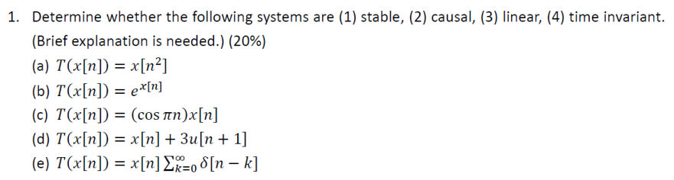

|  | Stable | Causal | Linear | TI |
| --- | --- | --- | --- | --- |
| (a) | O | X | O | X |
| (b) | O | O | X | O |
| (c) | O | O | O | X |
| (d) | O | O | X | X |
| (e) | O | O | O | X |

HW1-2 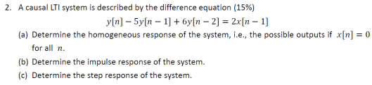1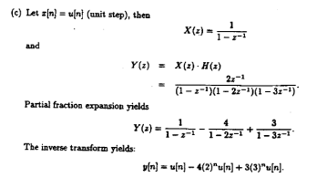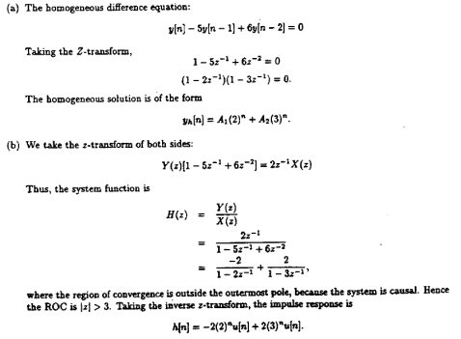

2

2

HW1-3

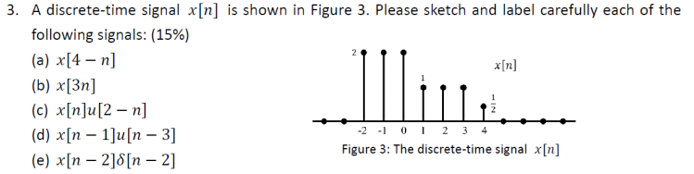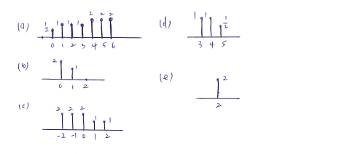

HW1-4

Periodic with fundamental period of π/4 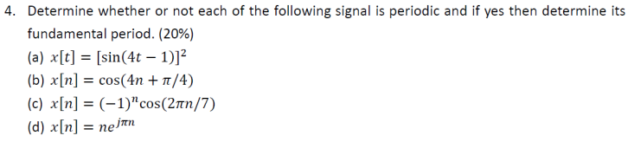

Aperiodic

Periodic with fundamental period of 14

Aperiodic

HW1-5

Some other method 7pts

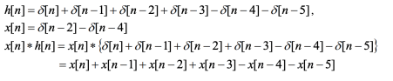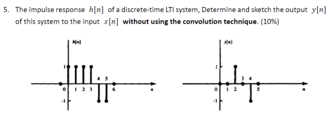5pt 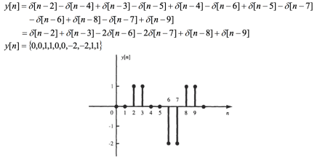

HW1-6 If not plotted some points has  been deducted

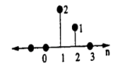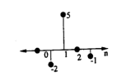

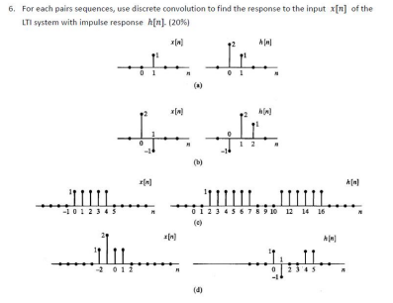

Quiz1-1



(a) Good for system analysis, practical implementation (Ref: Feb23-2022 p4)

(b) (1) Impulse response sequence (2) Convolution of impulse response and input sequences (Ref: Feb24-2022 p10)

Quiz1-2

Linear, time-varying (Ref: Feb23-2022 p10)

Quiz1-3

1 2 

2

寫錯一個 -3 points

( )2

Quiz1-4

w[n]=x[n]+1/2w[n-1] 

y[n]=2w[n]+w[n-1] → 3 points

y[n]-1/2y[n-1]=x[n]+2x[n-1]

Quiz1-5

(Ref: Feb24-2022 p13-14)

Quiz1-6

3

6

6

6

9

12

or

15 18 126

9

12 12 126

Quiz1-7





Quiz1-8

(Ref: Feb16-2022 p16-19) 

Aperiodic

Periodic with fundamental period of 35

Parseval’s Theorem Orthogonality property Orthogonality property 

HW

Continuous-time

Discrete-time

DTFT Properties

• Given a sequence �� �� with Fourier transform �� ������ , determine the Fourier transform of the following sequences in terms of �� ������ HW

Continuous-time Fourier Transform (CTFT):